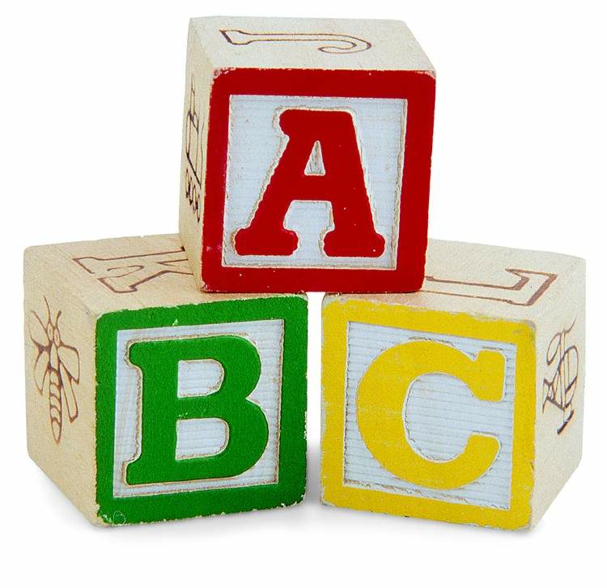
Fun Ways to Practice Letters or Words

Remember to have fun and keep it short while practicing letters and sight words.

- Games (Reminder only include a few unknown or confused letters)
- Go Fish (write each letter on two different note cards)
- Memory (use Go Fish cards)

- Shaving Cream
  - Student practices writing letter in shaving cream with their finger. They then say the letter name and sound each time they write it.

- Letter/Word Hunt
- Write letters or words on note cards and hide them around the house. Have your student say the letter name and sound when they find it.

- Shoe Box
- Decorate a shoebox to keep your known letters or words in and watch it fill up.

- Scrap booking
- Create a scrapbook by stapling construction paper together. At the top of each write a letter. Cut out pictures that begin with that sound and glue them to that page.

- Rainbow Writing
  - Write you words with different color markers or crayons.

